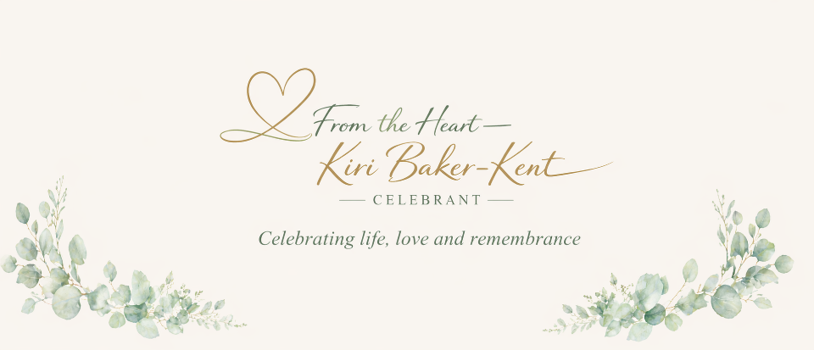

Funerals
Creating the Ceremony Your Loved One Deserves
Saying goodbye to someone you love is one of the hardest things we ever have to do. At such a tender time, I believe the ceremony should feel personal, comforting and truly reflective of the life that has been lived.
If you are looking for a celebration of life that offers more flexibility than a traditional religious service, I can help you create something meaningful and individual, a ceremony that tells their story in a way that feels right to you.
Every person is unique, and their farewell should be too.
I will take time to sit with you, to listen carefully to your memories, your wishes and what truly matters. Whether you know exactly what you want or feel unsure where to begin, I will gently guide and support you. Together, we will create a ceremony that feels authentic, respectful and full of love.

Funerals and Memorials
Whether you choose cremation or burial, the service can include whatever feels most meaningful. favourite songs, hymns, poems, readings or personal tributes. It can be traditional, contemporary or a thoughtful blend of both.
If family or friends would like to speak, I will support them every step of the way, helping them find the right words, offering reassurance and being there for them on the day.
Having worked in care for many years and as a Funeral Director, I understand how important it is that everything feels calm and well organised. I will work closely with your chosen Funeral Director to ensure the service flows smoothly, so you can focus on remembering and honouring your loved one.

Ashes Ceremonies
Scattering or burying ashes can be a deeply moving and meaningful moment, sometimes quieter and more intimate, but no less important.
Whether it’s a favourite beauty spot, a family garden or another special place, I can help you plan a ceremony that feels dignified and heartfelt. I will also guide you if permission is needed for your chosen location.
Together, we will create a moment that brings comfort and allows you to say goodbye in your own way.
It’s Your Service
This is your time to honour someone precious. My role is to walk alongside you with kindness, compassion and care, helping you create a farewell that feels personal, meaningful and truly reflective of the life you are celebrating.
You don’t have to do this alone.
Let’s chat - please contact me on kiri@fromtheheartcelebrant.uk or call 07872 426825

