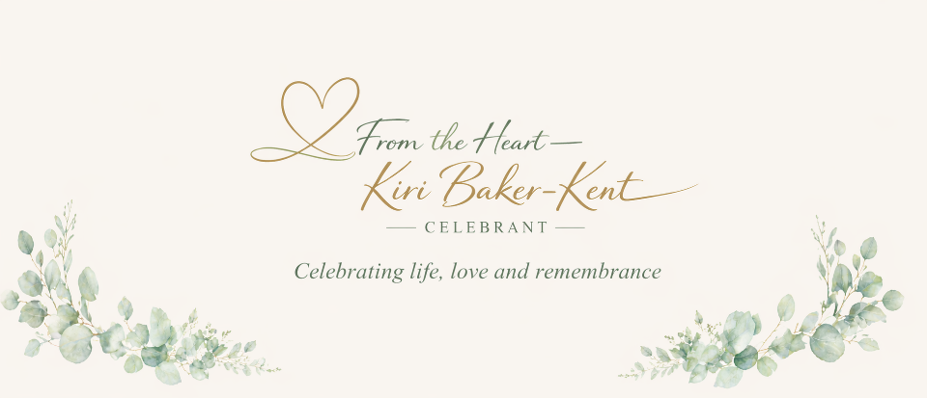

WEDDINGS
Together We Can Make Your Day Extra Special
Your wedding day is one of the most meaningful and memorable days of your life, and my role as your Celebrant is to help you create a ceremony that truly reflects you as a couple. I will work closely with you from the very beginning to ensure your celebration feels personal, relaxed and exactly how you want it to be — with complete flexibility to make it the day you’ve always imagined.
If you’re looking to renew your wedding vows, I would also be honoured to help you mark that special milestone with a ceremony that celebrates your journey together and everything still to come.
YOUR WEDDING YOUR WAY
When it comes to your vows, you shouldn’t feel limited by fixed wording or traditional scripts unless that’s what you want. Together we’ll create vows and a ceremony that come from the heart — telling your love story in a way that feels authentic, meaningful and completely unique to you.
One of the biggest advantages of a celebrant-led ceremony is freedom. There are no legal restrictions on where your celebration can take place, so you can choose a setting that truly reflects you — whether that’s a fairy-tale castle, a woodland setting, a beach, your garden or somewhere full of personal memories.
If you’re renewing your vows, this is your opportunity to celebrate your relationship in a way that reflects who you are now, with promises that are relevant to your life together today.
You have complete flexibility over the how, the when and the where.
DEDICATED TIME JUST FOR YOU
When you book me as your Celebrant, I commit solely to your ceremony on that day. Yours will be the only service I deliver, meaning there is no rushing between events and no time pressure. The day is yours to enjoy fully, at your own pace, with a ceremony crafted just for you.
My aim is simple — to help you create a celebration that feels relaxed, personal, memorable and truly yours.

Important Information About Legal Marriage
Please note that celebrant-led wedding ceremonies are not currently legally binding in England. This means that, in line with English law, you will need to complete the legal registration of your marriage separately with a Registrar at an approved venue before (or sometimes after) holding your bespoke celebrant wedding ceremony.
Many couples choose to take care of the legal paperwork at a simple registry office appointment and then have their personalised celebrant ceremony in the location and style they truly want, giving them complete freedom without restrictions.
You can find full details about the legal requirements for marriages and civil partnerships on the Government website here:
https://www.gov.uk/marriages-civil-partnerships/overview
If you have any questions about how this works alongside your celebrant ceremony, I’m always happy to guide you through the process.

Let’s chat - please contact me on kiri@fromtheheartcelebrant.uk or call 07872 426825

