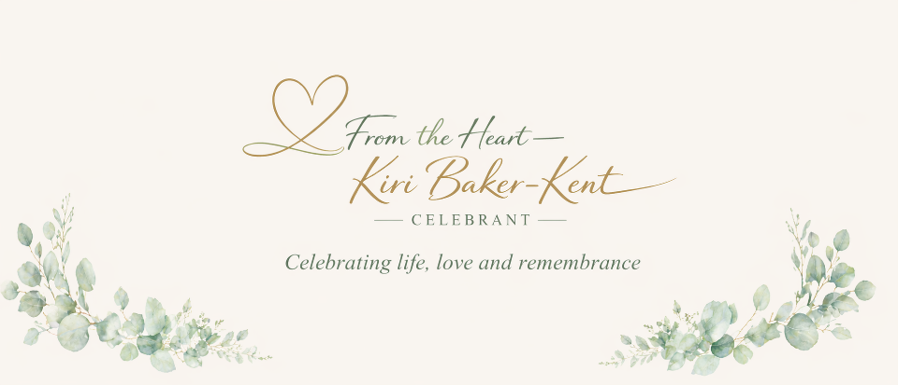

Other ceremonies

A Celebration for Every Occasion
Life gives us so many moments worth celebrating, not just weddings and farewells, but the quieter milestones, new beginnings and special memories that deserve to be recognised too. As a Celebrant, I love helping people mark these moments in a way that feels personal, meaningful and truly reflective of them.
Here are just a few examples, but if you have something else in mind, please do get in touch. If it matters to you, it matters to me. and together we can create something really special.

Baby Naming Ceremonies
Welcoming a child into your family is one of life’s most joyful moments. A baby naming ceremony is a lovely alternative to a traditional religious christening and focuses on celebrating your child in a way that feels right for you.
Whether your child is a newborn, toddler, older child or newly adopted, the ceremony is completely flexible. We can include promises from parents, grandparents or chosen supporting adults, symbolic elements, readings or anything else that feels meaningful to your family.
There are no restrictions on location either, your home, a garden, a favourite venue, wherever feels comfortable and special for you. It’s simply about celebrating your child surrounded by love.

Pet Funerals and Memorials
Our pets hold such a special place in our hearts. They are companions, comforters and part of the family, so saying goodbye can be incredibly emotional.
A funeral or memorial ceremony for your pet can provide comfort and help bring peace at a difficult time. Whether you choose somewhere meaningful to you or a quiet place of rest, I will work gently with you to create a ceremony that honours the love and memories you shared.

Other Celebrations
There are so many other occasions that can be marked with a celebrant-led ceremony, including:
- Adoption Celebrations – formally welcoming a child into their forever family
- Milestone Birthdays – celebrating a significant age in a meaningful way
- Anniversary Celebrations – marking years of love and commitment
- Retirement Ceremonies – honouring a lifetime of dedication and achievement
- Life Celebrations – recognising personal achievements or new beginnings
If you have an idea or a special moment you would like to celebrate, I would be delighted to help you bring it to life.
Whatever the occasion, we can create something personal, heartfelt and uniquely yours.
Let’s chat - please contact me on kiri@fromtheheartcelebrant.uk or call 07872 426825

